# Background

A coil winder is a machine that create windings around the metal core as well as for the air core magnetorquer. For the initial schematic, a stepper motor is used to rotate the support/metal core in place and pulls the wire from the spool that is held by a frame to provide translational constraint. This is a necessary tool because it significantly speeds up the process in creating windings as magnetorquers typically need about 200-400 windings. It also keeps consistent tightness around the material being wounded.

# Materials

1. Stepper Motor and Cables
2. Wire
3. Arduino Uno
4. Motor driver board
5. Decoupling capacitor ( at least 27 microF)
6. 12 V DC battery
7. Kapton tape
8. Adhesive
9. Bread Board

Bill of Materials

|  |  |  |  |  |
| --- | --- | --- | --- | --- |
|  | Qty | Unit Cost | Total Unit Cost | Link |
| Usongshine Nema 17 Stepper Motor | x1 | $10.99 | $10.99 | Amazon |
| BNTECHNO 30 AWG Copper Wire | x1 | $11.70 | $11.70 | Amazon |
| A4988 Stepper Motor Drive | X3 | $2.7 | $7.99 | Amazon |
| Total: |  |  | **$30.68** |  |

# Design

3 main parts

1. Axial rotator

* Rotate the material using a stepper motor.

1. Linear actuator

* Movies winding along axis of the material being wounded. This can be done manually or by a motor.

1. Spool

* Where the copper wire is wounded originally.

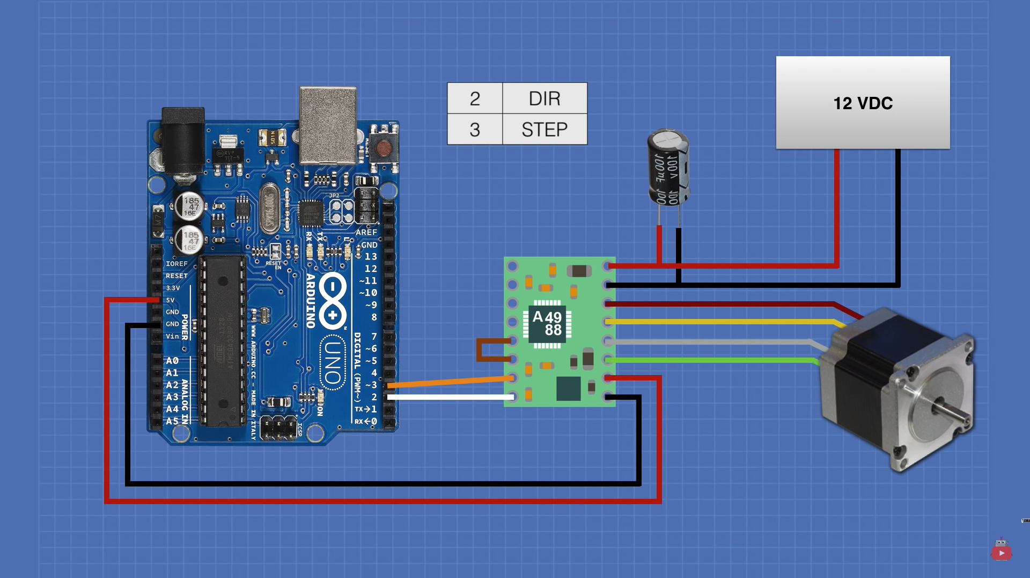

https://www.youtube.com/watch?v=0qwrnUeSpYQ&ab_channel=DroneBotWorkshop

# Reference

<https://www.youtube.com/watch?v=xkH2EJglwbk&ab_channel=BMonsterLaboratory>

<https://www.youtube.com/watch?v=GJcQfJ6JTZg&ab_channel=HyperspacePirate>

# Next Step

Check design with an experienced staff at the makerspace if its doable to build.